**DAILY ASSESSMENT-25**

Name: Vinutha S

Date: 03/01/2024

Creating Delta Lake Tables in Azure Databricks

1. First login to the Azure portal. Then create a Workspace as shown below.

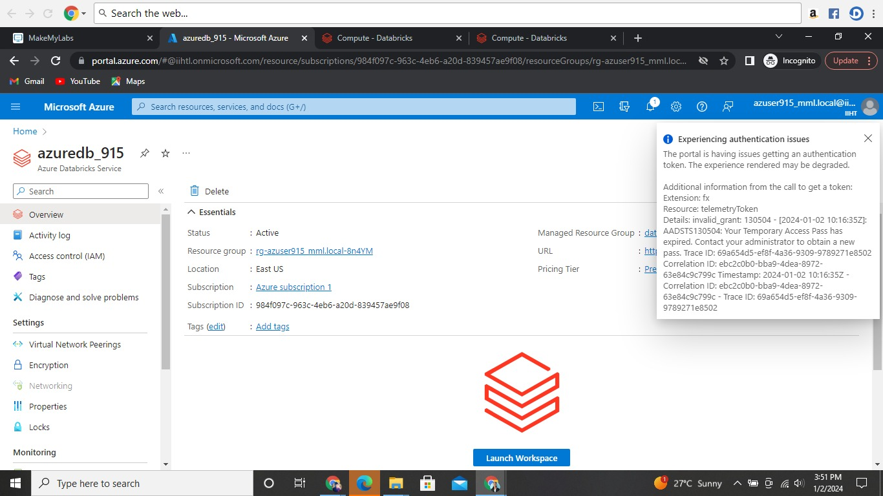

1. Created a Cluster in the workspace called azuredb_915.

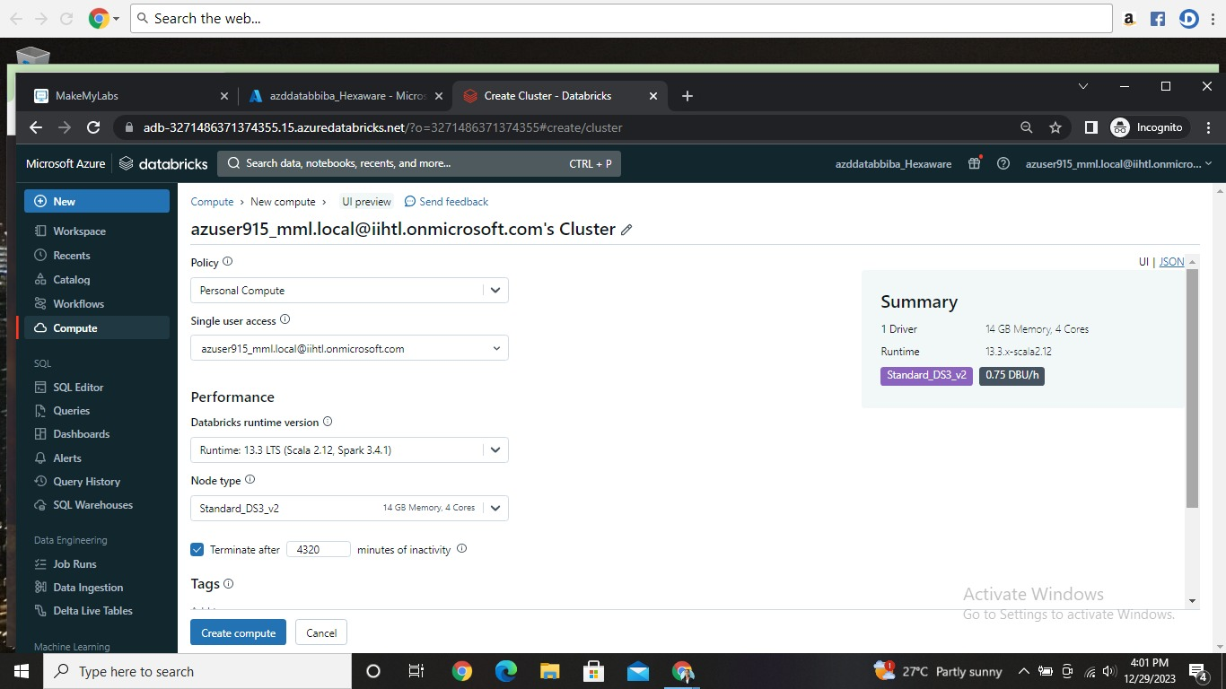

1. After having the workspace. I created a new table in Azure Databricks using an existing CSV file. Click on the **new-upload file**, then click create. which would open the interface as shown below after creating a table with sample data.

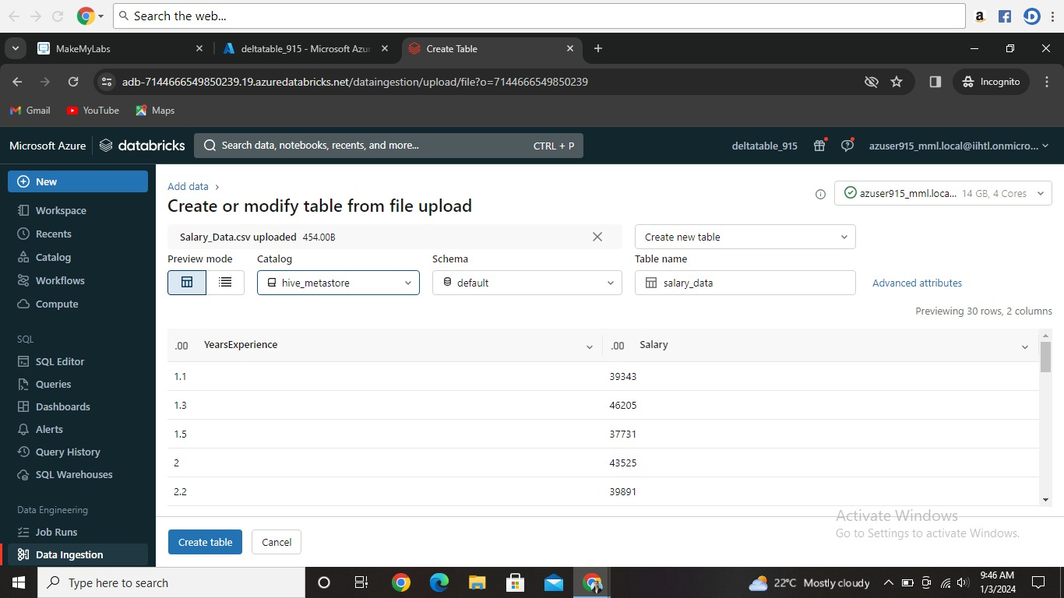

1. Click on **Catalog---Default** to see the overall information of the table including sample data, columns, details, history etc.

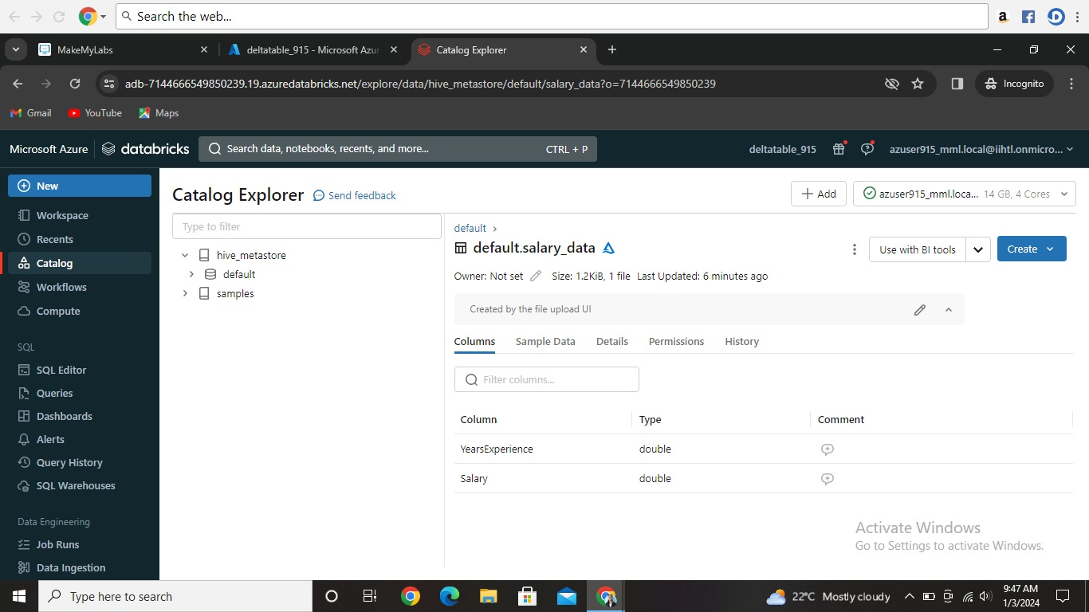

1. As shown in the above table by clicking create down arrow at top right will get options like notepad. Select notepad and create. Now the new notepad window will open with the code of two lines. Run the cell to get output table.

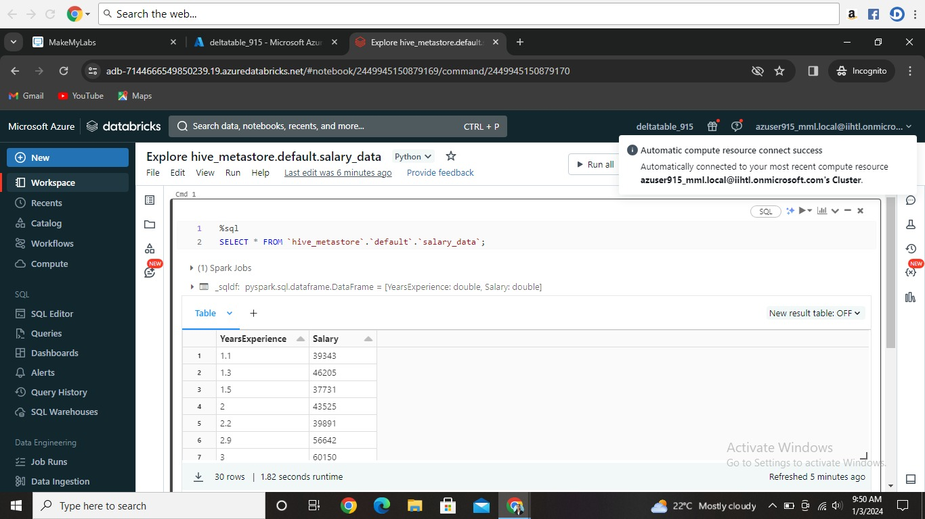

1. **We can also check the history of the table by clicking catlag at left.**

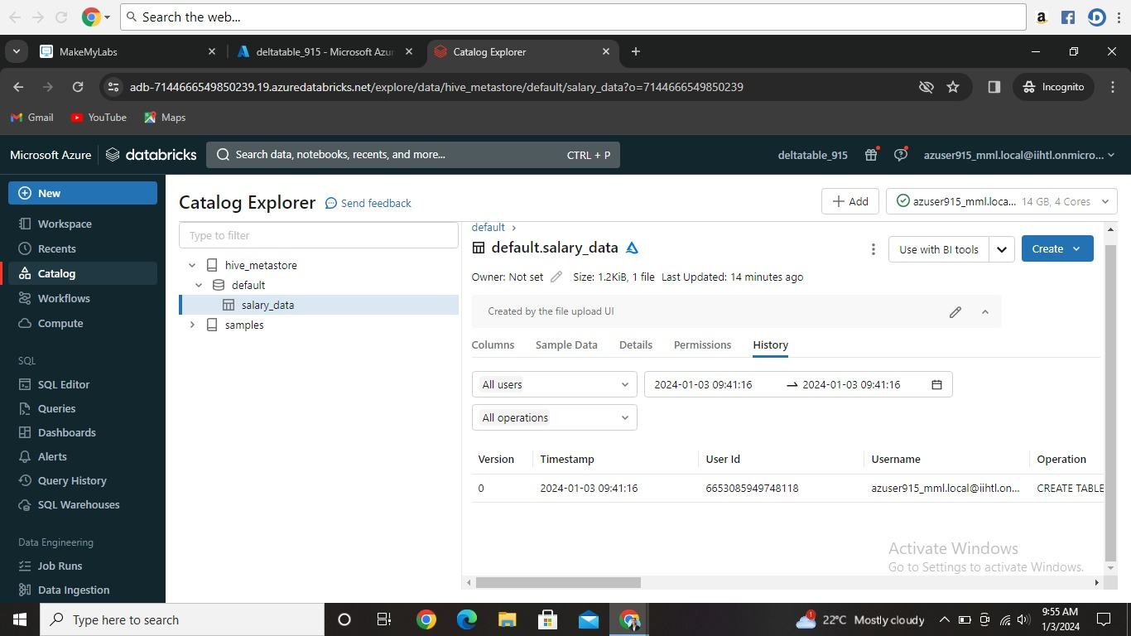

1. **My today’s workspace is as shown below.**

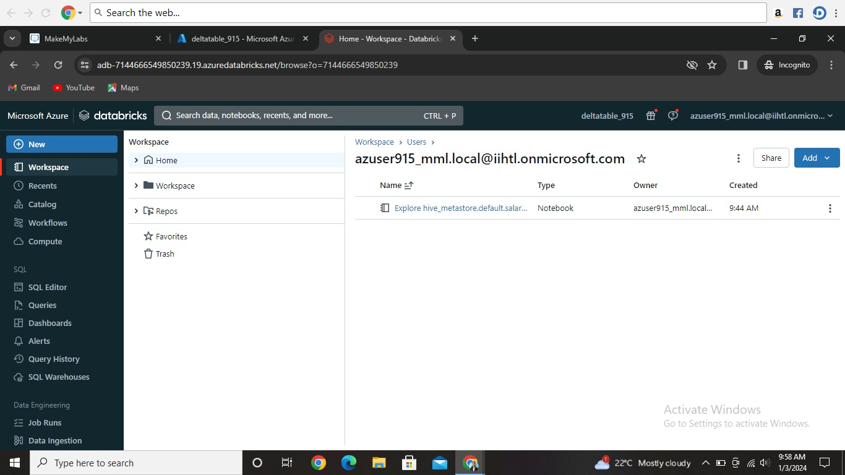

## Connect Storage Explorer to your Azure account

1. Login to Azure Portal. Created a new storage account. Inside that a cluster is created.

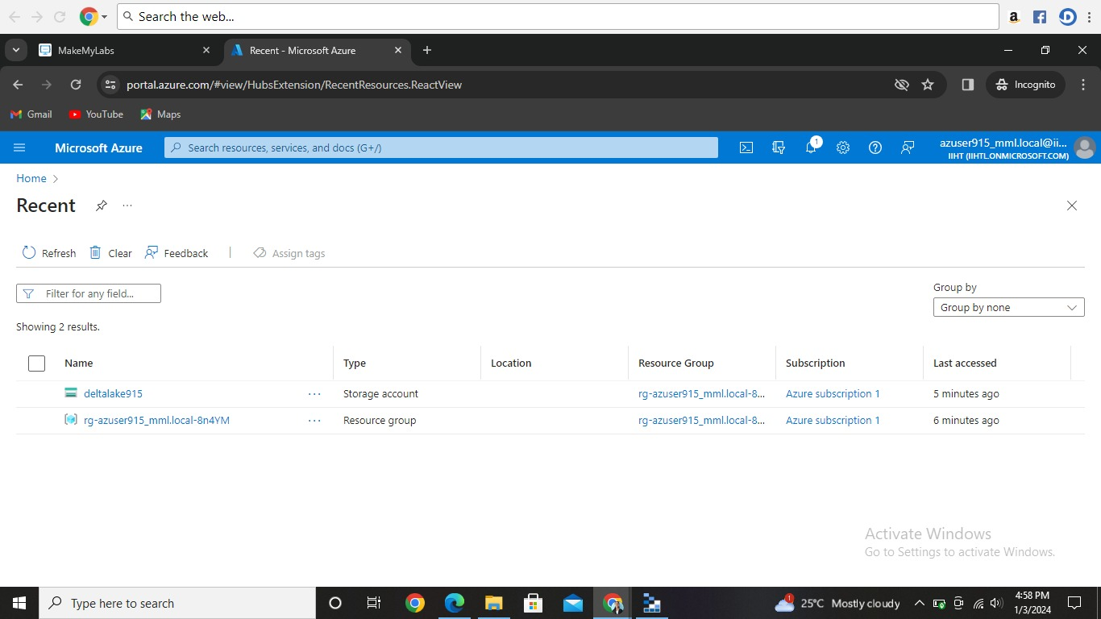

1. Downloaded a Microsoft Azure Storage Explorer which looks like below.

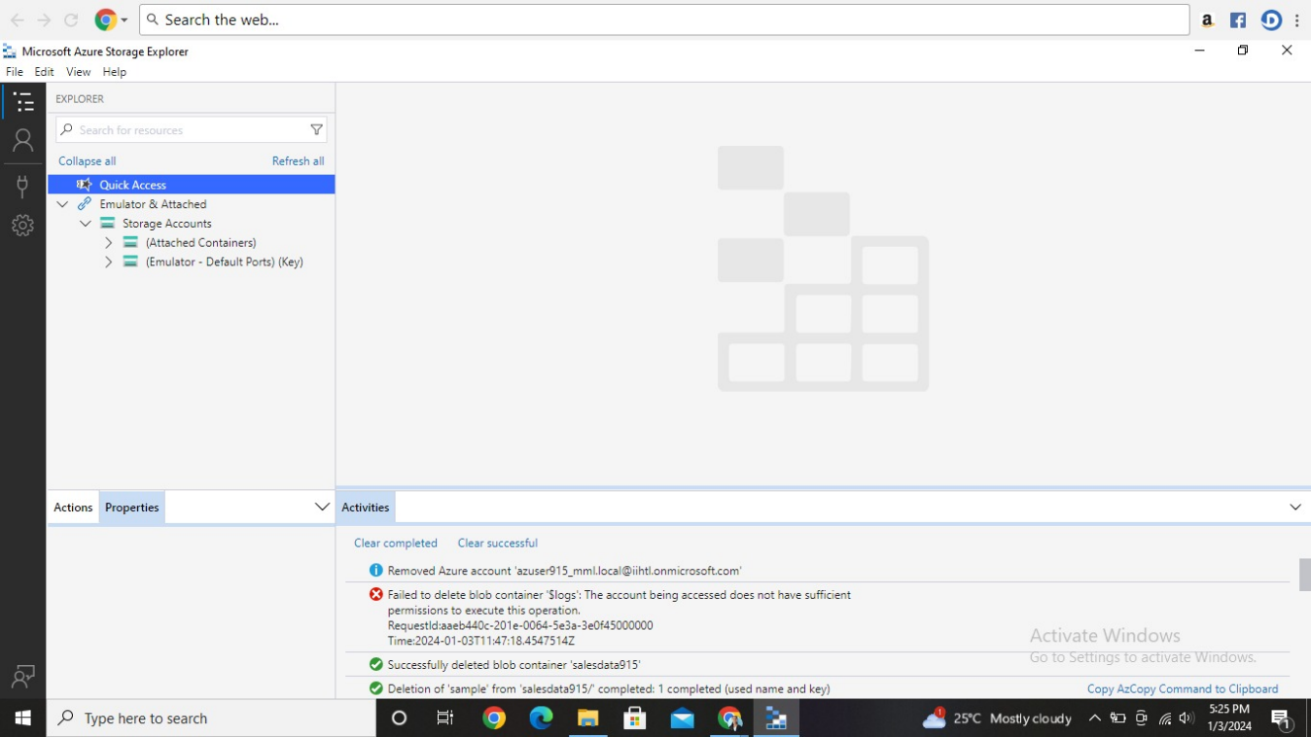

1. Once the storage account is created in the azure account it will be displayed in the Microsoft azure storage explorer. Selected my storage account named with deltalake915 by clicking down arrow selected create blob as shown in below picture.

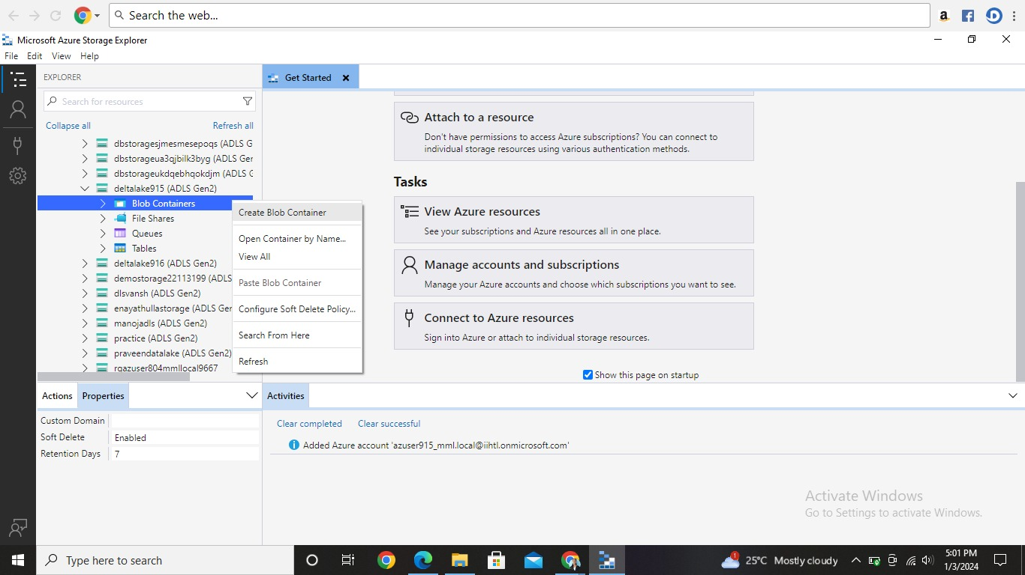

1. Created a new folder in the blob with the name “sample” inside that another folder is created named “data”.

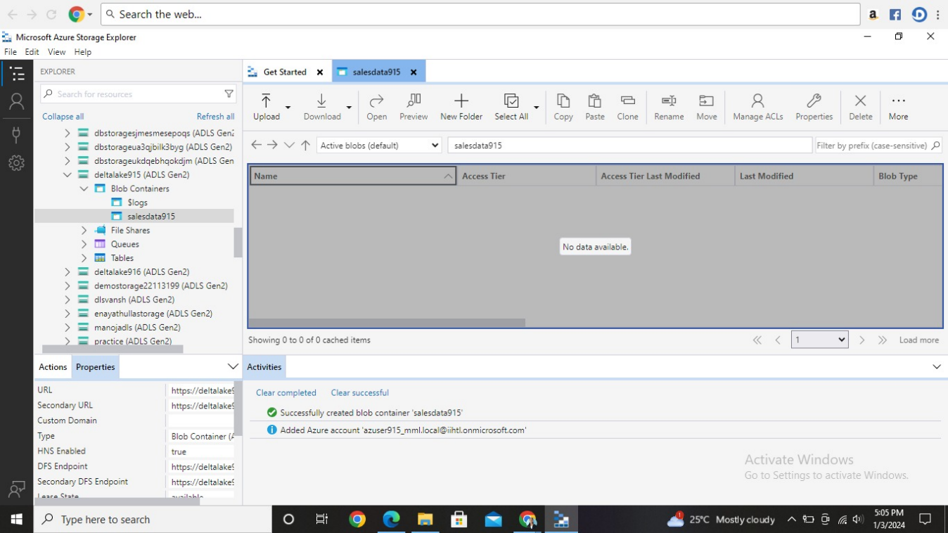

1. Inside the folder “data” I uploaded a text file called “sales.txt” as shown below.

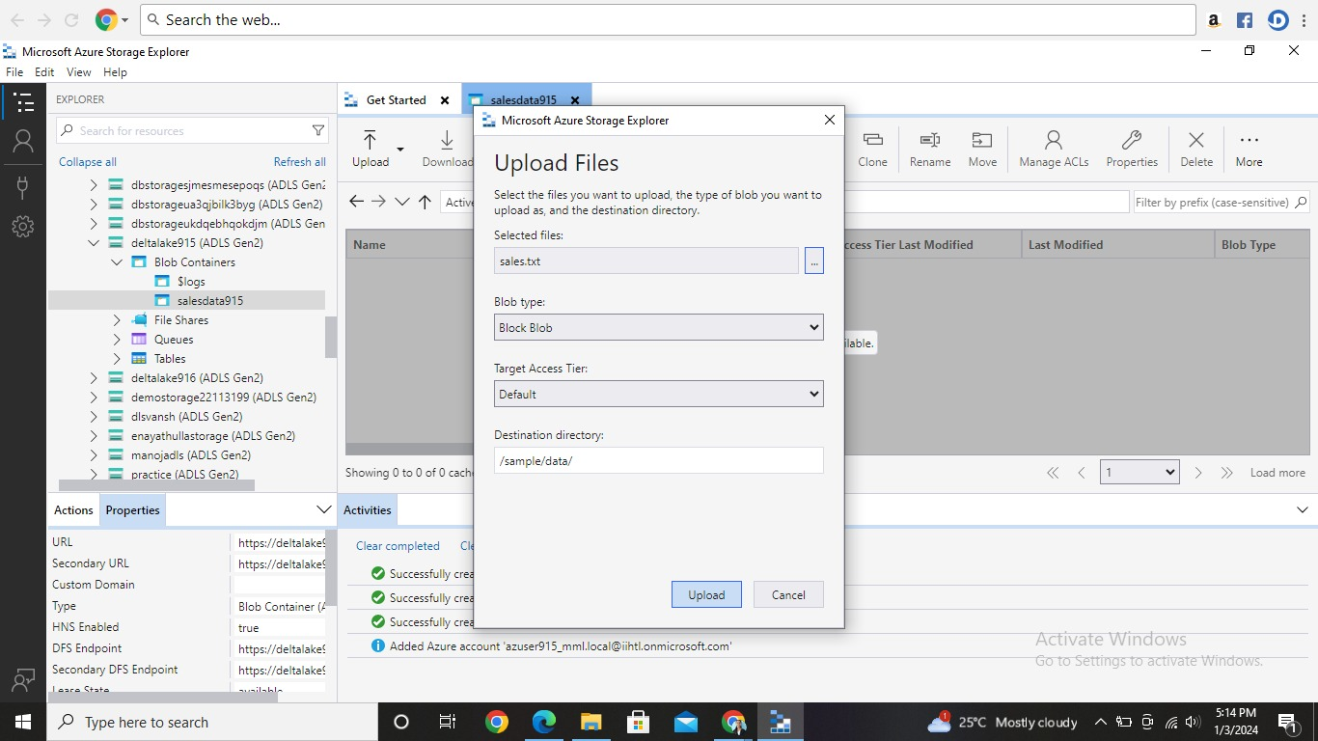

1. After uploading the file the page looks like this. (note: the notepad displayed on the screen is just for reference of what file contains)

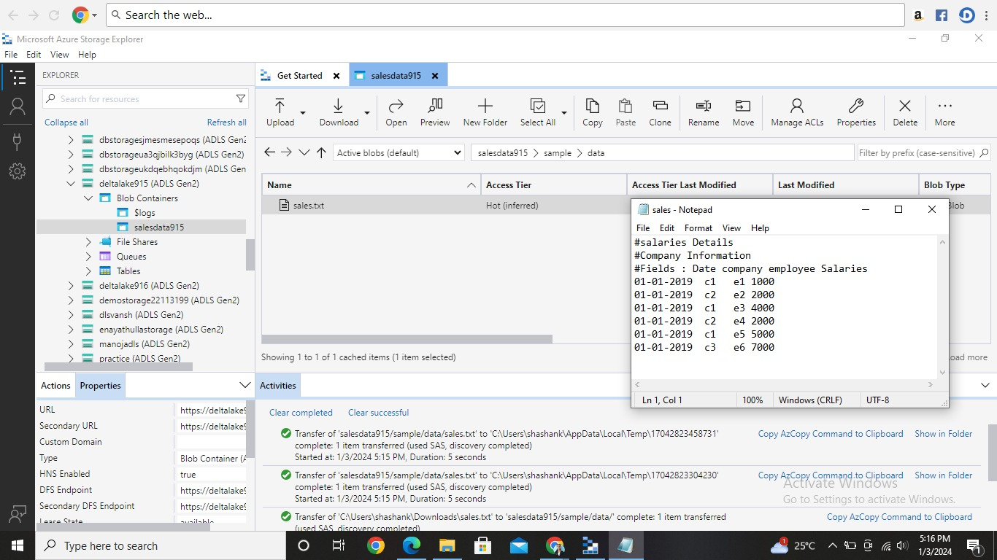

1. Likewise I also downloaded the file sales.txt to wished path in my pc.

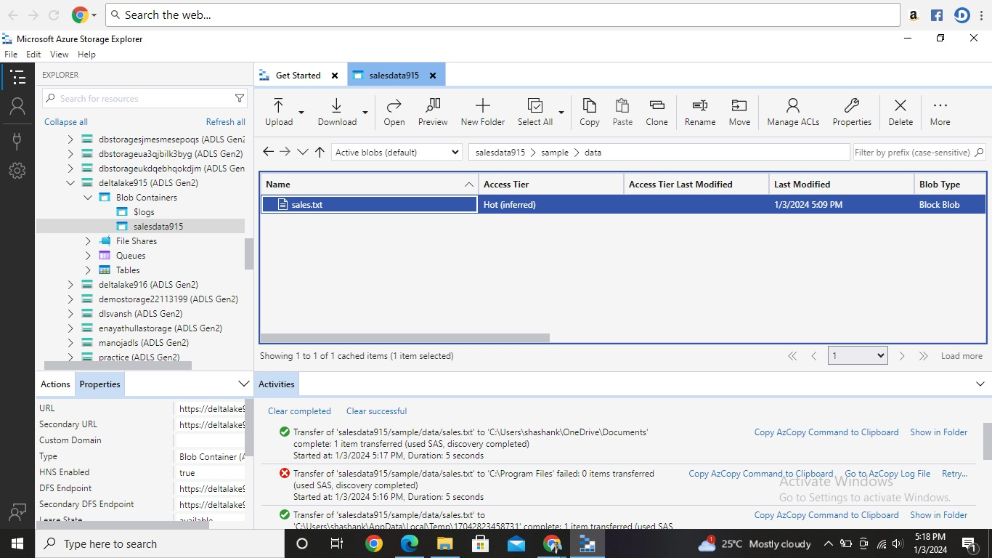

1. After taking ss I deleted all the storage accounts.